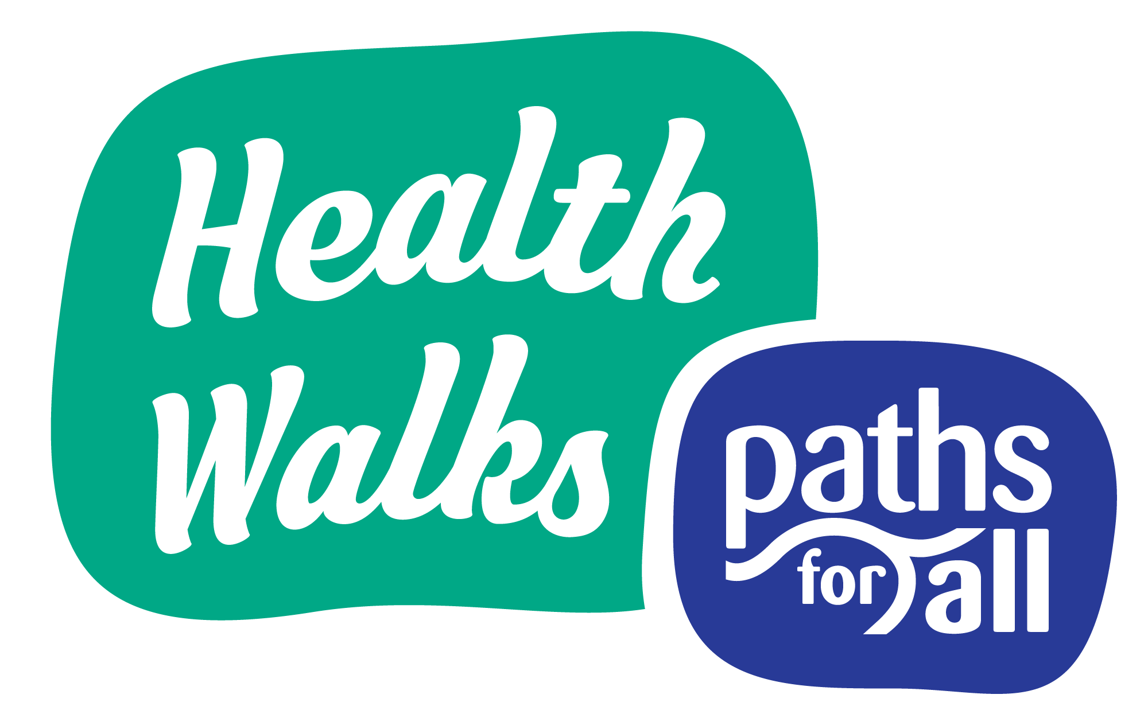
Walk Agreement Card (amended for Health Walks during physical distancing)

Version 9: 17th May 2021

How Walk Leaders should use this card
Stand 2 metres away from the group when welcoming walkers and remind them what 2 metres looks like and to keep distant from each other as they gather.
Read this card aloud to the group at the start of each walk, instead of passing it from one person to another. It may have been shared on social media or made available to walkers in advance. Make it clear to walkers that their participation in the walk means they consent to walking under these terms.
One Walk Leader should take a verbal Walk Register instead of passing around a sign-in sheet.
Refer to Paths for All’s ‘Practical guidance for Volunteers restarting Health Walks’ for further guidance.

Walk Leader Agreement
As Walk Leaders we have committed to the following:
- We have tried to make this walk as safe as possible by doing a risk assessment of the route. This included trying to find a quiet route with plenty of space.
- All staff and volunteers leading this walk have done the Paths for All Walk Leader training course.
- We have tried to find a walk that is suitable for everyone, bearing in mind some of us might not have been very active for a while and may need to take things easy at first.
- We will describe the route and any hazards to you before we start walking and will let you decide how far you want to walk.
- We reserve the right to ask a walker to leave the walk if they are displaying symptoms that could be related to Coronavirus or are putting others at risk by not following physical distancing guidelines.
Unfortunately, we can’t guarantee that toilet facilities will be available on this route since they may be closed due to the Coronavirus.

Walker Agreement
By taking part in the walk, you are agreeing the following:
- I won’t take part in the walk if I should be self-isolating, have been overseas and are required to quarantine in the past 10 days or am displaying symptoms that could be signs of the Coronavirus (according to Scottish Government’s most recent guidance).
- I’ll provide my contact details for the purpose of being contacted through the Track and Trace system if required.
- I’ll only walk if I am fit and well enough, and it’s up to me to assess if I can do the Health Walk safely.
- If I have any concerns about my ability to participate in the walk, I’ll talk to a Walk Leader or a health professional.
- I’ll keep at least 2 metres away from other walkers and Walk Leaders at all times (unless we are from the same household).
- I’ll cover my nose and mouth if I need to cough or sneeze and will put used tissues in a bin.
- I’ll use hand gel or wash my hands as soon as I get home.
- I reserve the right to wear a mask or face covering if I’m concerned about maintaining a 2 metre distance from others and feel safer doing so.
- I’ll be mindful of other members of the public during the walk and stand to the side to maintain physical distance and let them pass if necessary.
- I’ll tell a Walk Leader if I feel unwell while out on the walk or if I am leaving the walk before it has ended.
- If I develop Coronavirus symptoms following the walk, I’ll notify Test and Protect teams of my contact with the group and pass on details of the Project Coordinator.
- I understand that I come on this Health Walk at my own risk.

Finally, as walkers and Walk Leaders we agree to respect each other.

