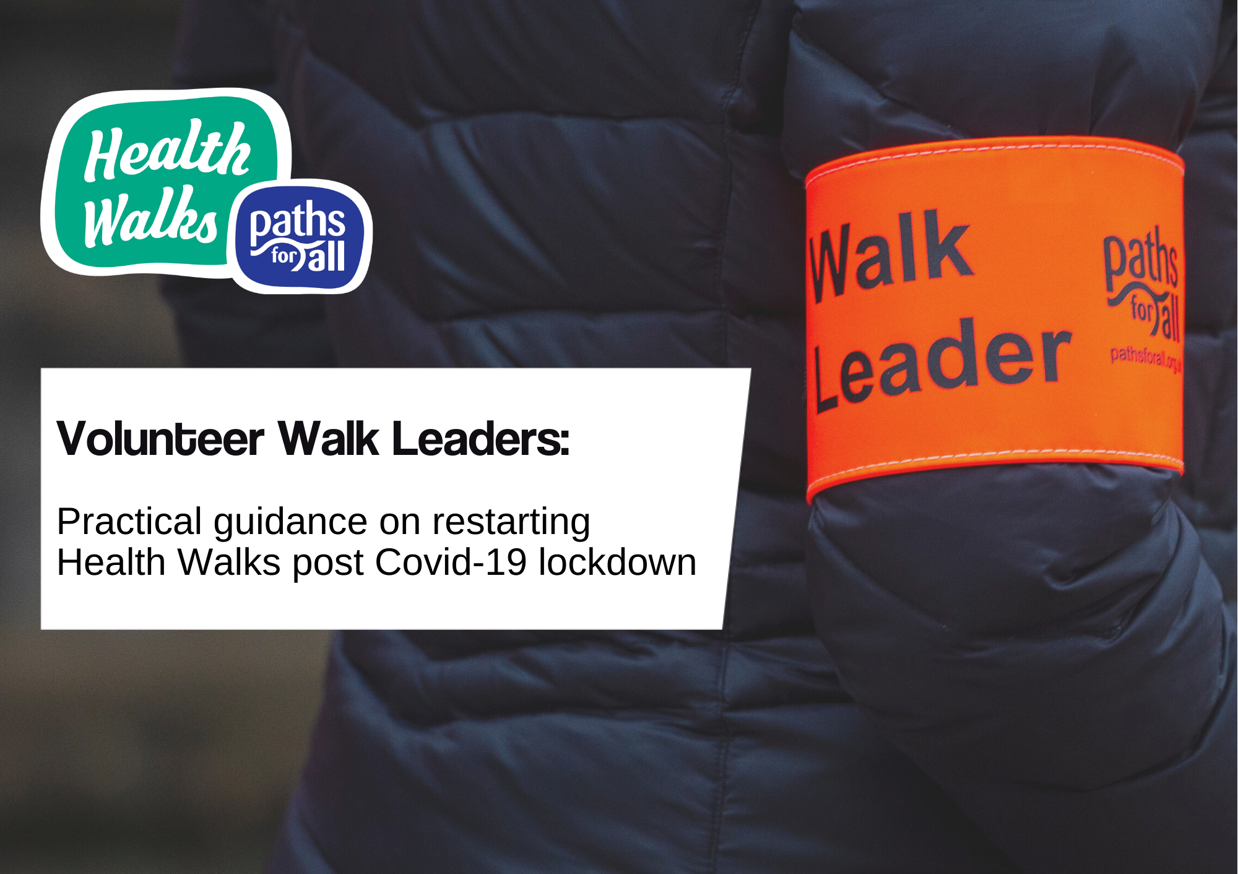
Version 9 17th May 2021. Paths for All Partnership is a registered Scottish charity No. SC025535

Paths for All have produced this guide to provide practical advice to Walk Leaders restarting volunteering post lockdown.
We are incredibly grateful for the time gifted by Volunteer Walk Leaders across Scotland to support people to get more active and socially connected. The COVID-19 outbreak has affected all our lives, in many ways, over the last year and it is likely it will continue to do so for some time to come.
While the thought of returning to lead Health Walks may be a cause for celebration for some Walk Leaders, it may leave others feeling anxious and uncertain. This brief document is designed to help you think about what your role might look like now, and can be used alongside our Walk Leader flowchart, to help you make an informed decision about returning to volunteering as restrictions ease. It is underpinned by the following key principles:
Personal Safety and wellbeing must come first
There is no expectation for anyone to continue a Walk Leader role or to take part in any activity which makes them feel uncomfortable or at risk. Individual circumstances will vary hugely, and we understand that it will not be possible for all volunteers to return in the near future. Some volunteers may wish to test out leading a walk – when it is possible – without committing to returning more fully or undertake a different, more remote, volunteering role. We are encouraging projects within our network to take a flexible and supportive approach to welcoming back volunteers.

Volunteers must be led by national and local guidance
Scottish Government guidance has been reviewed and restarting Health Walks is now possible within the guidelines. Decisions on restarting and expanding Health Walks should be made within your project and will depend on local factors such as: volunteer capacity, accessibility and popularity of routes and, if you are supported by a managing organisation, their own risk assessment and insurance processes. You must stick to the guidance issued to ensure your walk is as safe as possible for you and your walkers. For projects solely managed by volunteers, you should use the Scottish Government guidance alongside Paths for All’s, considering your own needs and local context.

Openness and honesty
There is no doubt we find ourselves in unprecedented and strange times. We are all experiencing new challenges we could not have foreseen. Please feel encouraged and enabled to raise any concerns or challenges with your project coordinator, or directly with your Paths for All Development Officer if you do not have organisational support, so that these can be addressed.

New considerations in your Walk Leader role
Below you will find questions and answers outlining the stages of a Health Walk, the new considerations arising as a result of COVID-19, and some practical guidance on how to deal with these new considerations.

What does COVID-19 mean for our routes?

It is likely that existing routes may need to be modified and the risk assessment process repeated for all routes. Paths on regular routes may have become neglected or are falling into disrepair during the lockdown e.g. overhanging branches not being cut back, making paths narrower and harder to walk along, especially for groups. Try to avoid busy places where physical distancing may prove difficult and plan in some shorter options as part of your route to accommodate for those who are returning to walks after a period of inactivity. We have produced an updated risk assessment form which you may want to use.

How should we gather before the walks begin?

The guidance now suggests a maximum of around 30 people can attend a Health Walk, with no restrictions on the number of individual households . This doesn’t mean there is an expectation that every walk now has 30 people attending. The appropriate numbers attending will be dictated by the number of volunteers available and the suitability of the route to accommodate larger numbers of walkers. You should gather outdoors, where you do not obstruct access for other path users. Fostering a physically distant culture on Health Walks, for the time being, will be important. It’s important to lead by example in this case – so greet walkers in a physically distant way from the outset so you can set a new ‘norm’ which walkers will then be more likely to mirror. This means that you, and any other Walk Leaders, should stay 2 metres apart from each other and the walkers at all times.

How do we encourage our group to remain physically distant?

The numbers of walkers permitted in each group, although increased, is still limited. This number will likely change in the future as Scottish Government guidelines change. Projects may choose to have a booking system to attend walks to make sure numbers are kept at a safe and permitted level.

Walkers will be asked to agree to comply with the requirements of our updated Walk Agreement, at the start of each walk. This will be read out by a Walk Leader at the start of the walk, or circulated in advance, rather than being passed around like it usually is. It outlines measures that we’ll take to make the walks safe for everyone.

At this time, when meeting with other households, individuals must remain at least 2 metres apart from each other. Retaining physical distancing is a shared responsibility amongst the whole group and something we must do to protect ourselves and each other as well as to ensure the walks can still run at this time – even if we do not always find it easy or natural to do.

As a guide, 2 metres is roughly the height of an average door, or two length-ways shopping trolleys pushed together. It may help to communicate this distance to your group visually at the start. By emphasising the shared responsibility of physical distancing, you will make it easier for your group to keep themselves in check. You might want to nominate someone to be a ‘Distance Monitor’ on the walk with a role to keep an eye on walkers and remind them in a friendly way if they start to move too close together. Or encourage walkers to say “we’re getting too close” and make a correction themselves if their distance begins to reduce. At the end of the day, no one should feel awkward or offended by looking out for themselves or others.

How should we handle the paperwork?
Paperwork, and shared pens, could pose a cross-contamination risk and so you should eliminate all shared contact of objects and not pass paper or pens between the group.
Sharing the Updated Walker Agreement
We have updated our Walk Agreement to underline the key messages to walkers at this time. These include:
- Ensuring all walkers realise they take part in Health Walk activity at their own risk
- That walkers should not put themselves or others at risk by participating if showing COVID-19 symptoms
- That the group must remain physically distant at all times in order for the walks to run and to look after themselves and others
- The group must agree that their phone numbers may be shared for track and trace purposes
- This should be read out at the start of the walk, or shared beforehand, and walkers should understand that their participation in the walk means they consent to walking under these terms.

Walk Registers
When taking the register, one Walk Leader should take responsibility for the register, clipboard, pen, etc. and these should not be passed around. The Walk Registers should be sent to the Project Coordinator after the walk.
- When walks re-start it is likely these will be for smaller groups of existing walkers, so the Walk Leader should be able to note down all the names on the register quickly.
- The Walk Leader should ask any new walkers to give their name verbally and add this to the register rather than passing the register and pen around.
- Make sure you capture walkers’ phone numbers on the register as these may be required for contact tracing purposes.
New Walker Forms
Paper New Walker Forms should not be used at the current time, to ensure paper and pens are not shared. However, it is important that any new walkers are registered – there are several ways of doing this:
- Consider digital: For new walkers with their own smartphones or tablets, they can complete a New Walker Form at https://www.pfadatabase.org.uk/register - just make sure you give them your walking project name to input along with their own details (e.g. Health Walks West Dunbartonshire, Walk Aberdeen, Letham Happy Wanderers)
- Offer to take their details verbally and complete the form on their behalf: This may be slightly more time-consuming, and some details may be sensitive, so you may wish to offer this after the walk is completed and other walkers have dispersed, if you can find a quiet area
- If neither of these options are suitable, capture the walkers’ name and a contact email address and/or phone number so that it can be followed up at a later stage. For example, the Project Coordinator could phone the walker afterwards and complete the form with them over the phone.
What else should we consider as we set off?
Be mindful that returning to activity after time away may mean that walkers are not able to walk at their former pace and that some may find activity more challenging than they expect. Be aware that people’s strength and balance may have been affected by reduced activity during lockdown, so remind people to take extra care when on steps or obstacles.
Use your gentle 5-minute warm up at the outset of the walk to get a sense of your group’s ability. Check in with your walkers and ask them how they are doing. Only increase the pace of the walk if it is appropriate for the group. Remember there are some helpful tips on getting the pace right in your Walk Leader Training Manual. Having a shorter loop on offer as part of your walks may be helpful, too, for those who are coming back to activity after a break.

What should we consider when crossing roads or giving way to other path users?

Physical distancing rules could easily be broken when distracted by crossing roads or giving way to other path users. You may wish to use this opportunity to remind walkers to stay 2 metres apart and not to cluster together when crossing roads or giving way to other path users. Make sure to continue to lead by example.

How can we continue to demonstrate Strength and Balance exercises on our walks?

For groups whose Walk Leaders have completed Strength and Balance training, you may wish to continue to offer a demonstration of these activities for your walkers. If you are able, you should consider how to do this safely and in line with the current government guidelines around participation numbers and social distancing, and a risk assessment must be carried out prior to demonstrating the exercises. Here are some pointers:

- Give a brief introduction to Strength and Balance activity before commencing, outlining that participants take part at their own risk
- You may find that not all walkers will want to participate in this activity, so it may be best to leave Strength and Balance exercises to the end of your walk to make it easier for walkers to opt-out
- Ensure participants from different households remain at least 2m apart at all times
- Ensure your participants have sufficient supports – such as chairs, railings, walls or park benches - and a flat surface to stand on to undertake this activity.
- Seek to minimise cross-contamination by encouraging participants to use gloves when touching outdoor supports if outside (or using hand sanitiser before and afterwards) and by cleaning all surfaces inside before and afterwards, as well as promoting hand hygiene.

How should we deal with illness or injury?
Walking is a low-risk activity, and instances of injury are usually few and far between. In the unlikely event that someone falls or becomes unwell on a Health Walk, we would not expect walkers or volunteers to feel obligated to put themselves at risk by breaking physical distancing rules to provide assistance.
Here are some guidelines:
- Communicate with the injured or unwell individual, from a safe distance, to ascertain the severity of the situation. If the walker seems unhurt encourage them to get up slowly - this advice might be helpful https://www.nhsinform.scot/healthy-living/preventing-falls/dealing-with-a-fall/what-to-do-if-you-fall If the injury or illness appears to be serious, call 999 immediately and stay with them until help arrives as normal.
- In situations where there is no need for immediate medical attention, or for minor first aid only, Public Health Scotland’s advice for volunteers is ‘At times you might be carrying out very specific activities, outwith a premises, where it is not possible or practical to guarantee the minimum of 2 metre social/physical distancing measures. In these circumstances we recommend that you read the Scottish Government advice on facial coverings.’
- We recommend that volunteers carry a face mask or covering and hand sanitiser for this purpose but we reiterate that no one should feel obligated to put themselves in a position in which they feel uncomfortable.

For volunteers whose walking groups sit within a managing organisation, your project coordinator may be able to give you more information on local protocol for dealing with injury or illness. An accident/incident form must be completed and passed to Paths for All after every incident even if it doesn’t seem serious at the time. You should also document any Covid-19 precautions/measures taken on the form, for example physical distancing measures, wearing a face covering, using hand sanitiser etc.

What can we do instead of our post-walk cuppa?
At the moment the opportunity for post walk social activity varies depending on what level your area is on. In levels 2 and 1, walkers and volunteers can meet inside cafes in groups of up to 6 people from three households or 8 people from three households and either 8 people from 8 households or 12 people from 12 households for a post walk social gathering outside.
You could also arrange a video call to replace in person social gatherings after the walk or on a different day while we aren’t able to meet in larger numbers socially, face to face.
Raising questions, concerns or issues
If you have questions, queries or concerns about your volunteer role or undertaking Health Walks, please raise them with your project coordinator (or with your Paths for All Development Officer if you do not have a managing project) as soon as you can.
It is important we are open with each other about the challenges faced at this time so that we can tackle them together.

