Meet the
Walking for Health
Development Officers

Our Walking for Health Development Officers are here to provide support and guidance to all Scottish Health Walk Network Members. If you have a question, or would like to reach out, simply click your area below to find out about your contact.

Aberdeen City | Aberdeenshire | Angus | Argyll and Bute | Cairngorms National Park | Clackmannanshire
Dumfries and Galloway | Dundee | East Ayrshire | East Dunbartonshire | East Lothian | East Renfrewshire
Edinburgh City | Falkirk | Fife | Glasgow City | Highland | Inverclyde
Loch Lomond Nat. Park | Midlothian | Moray | North Ayrshire | North Lanarkshire | Perth and Kinross
Renfrewshire | Scottish Borders | South Ayrshire | South Lanarkshire | Stirling | West Dunbartonshire
 | West Lothian | Orkney Isles | Shetland Isles | Western Isles

Aberdeen City, Aberdeenshire, Cairngorms National Park, Highland, Moray, Perth and Kinross
Hello, I’m Helen Wilson – a Development Officer supporting walking for health projects in Aberdeen City, Aberdeenshire, the Cairngorms National Park, Highland, Moray and Perth & Kinross.

I’ve been working for Paths for All since 2012 and am based in Inverness. My background is in environmental project and policy work and outdoor recreation, and I enjoy this job as it combines my interests in physical activity, health and the environment.
Please don’t hesitate to contact me if you have any queries or would like any support.
Email: Helen.Wilson@pathsforall.org.uk
Call: 07590350390 / 01463 725159

Angus, Dumfries & Galloway, Dundee, North and South Lanarkshire.
I am Claire McMenamin – your Development Officer for Dumfries & Galloway Angus, Dundee, North and South Lanarkshire. As well as supporting Health Walk projects in the area, I am also responsible for coordinating the teams work to promote active and sustainable travel.

I have been working for Paths for All since 2017. Previous roles involved supporting the Macmillan Move More projects across Scotland and then promoting workplace walking as a member of the workplace team.
I’m passionate about health promotion, building community capacity and making a positive difference to people’s lives.
Please get in touch, I am happy to help.
Email: Claire.Mcmenamin@pathsforall.org.uk
Call: 07590 350 388

Argyll & Bute, Clackmannanshire, East Ayrshire, Falkirk, Loch Lomond National Park, North Ayrshire, South Ayrshire, Stirling
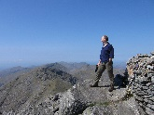
I’m Colin and have a lifetime love of walking. From dog walking with my father as a kid, to countryside adventures with my children and mountain escapades with friends. For me walking has been the bedrock of life providing fun, social wellbeing and exercise.
With a professional background covering countryside rangering, outdoor access and education - I understand the motivations required to get people walking and change behaviour. I believe in the power of walking and the way it enhances lives, communities and society.
Together we will get Scotland walking. Contact me and we can start that conversation.
Email: Colin.Ward@pathsforall.org.uk
Call: 07540214905

East Dunbartonshire, East Renfrewshire, Fife, Glasgow City, Inverclyde, Renfrewshire, West Dunbartonshire

Hello, I’m Nicole Bell – your Development Officer for Greater Glasgow and Clyde, Fife, Dundee and Angus. I joined the team at Paths for All in September 2018 having most recently worked with a mental health charity and, before that, in local government.
I’m particularly passionate about long-term physical and mental health issues and how we can use physical and social activity to enhance people’s overall wellbeing, resilience and sense of community. Health walks seemed like a perfect fit for this!
If I can be of any help to you whatsoever, please don’t hesitate to get in touch.
Email: Nicole.Bell@pathsforall.org.uk
Call: 07590350393
Tweet: @NextStepNicole

East Lothian, Edinburgh City, Midlothian, Scottish Borders, West Lothian, Orkney Isles, Shetland Isles, Western Isles
I’m Valerie Carson, Development Officer for the Lothians, Northern and Western Isles and the Borders. I support a range of Walking for Health projects at all stages of their development, from starting up to exit strategies.
I’m particularly interested in the inter-connectedness between physical, mental and social health; and in making Health Walks accessible and inclusive to all.
In previous roles I’ve supported 100s of third sector organisations to increase community involvement, reduce carbon emissions, improve volunteer management practices, and increase access to services for people with characteristics protected by the Equality Act and/or living in poverty.
Email: Valerie.Carson@pathsforall.org.uk
Call: 07391 869601

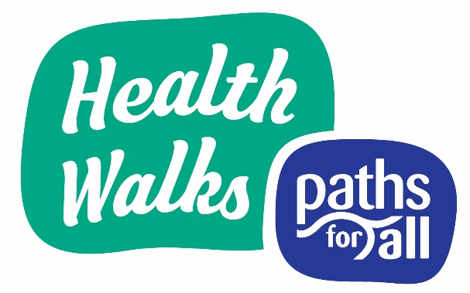

Paths for All is a partnership organisation. For a full list of our current partners please visit our website www.pathsforall.org.uk.
Paths for All Partnership is a recognised Scottish Charity No: SC025535 and a Company Limited by Guarantee No: 168554 incorporated 19 September 1996 at Companies House, Edinburgh Registered Office: Kintail House, Forthside Way, Stirling, FK8 1QZ

