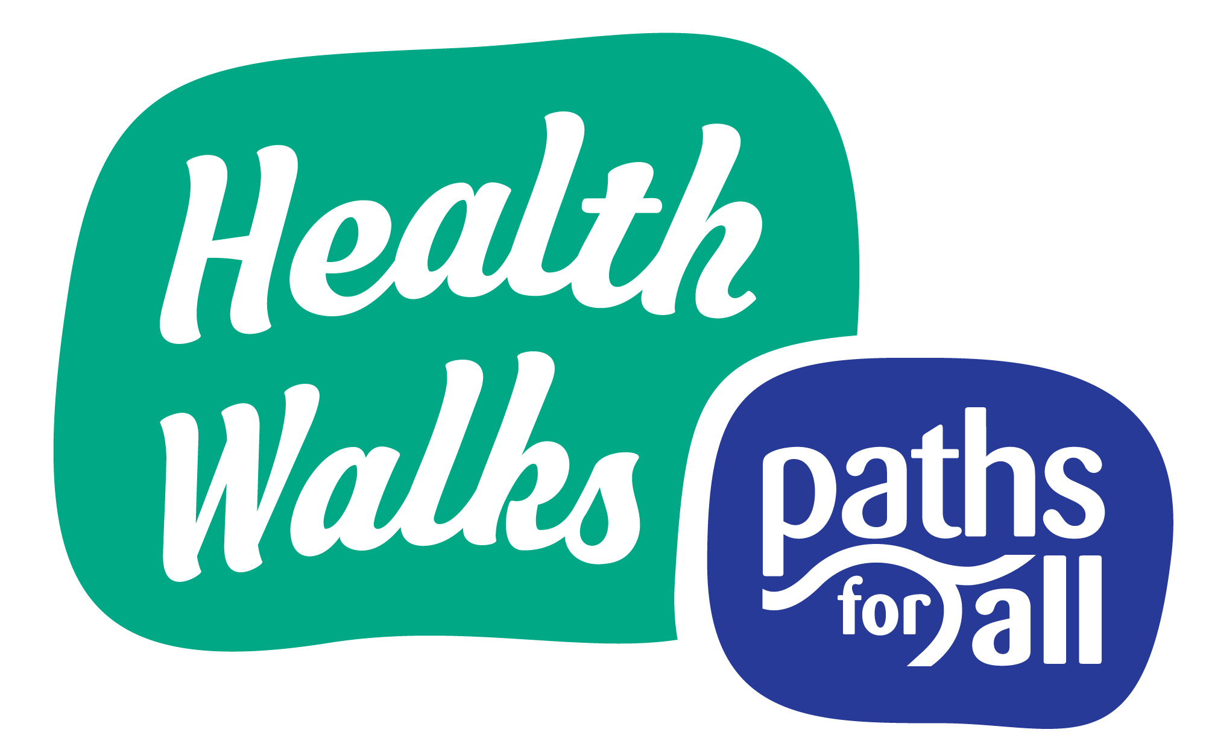
Health Walk Risk Assessment Template (Covid-19)
Version 13
(created: 23rd March 2022)

Route

Date

Assessment carried out by

We have updated this Risk Assessment template for you by including guidance related to the spread of Covid-19. It can be used as a guide to completing a full risk assessment.

Your project may have its own Risk Assessment guidance and template – please discuss this with your Project Coordinator, if you have one, who will be able to advise you.

If you don’t have a Coordinator, you can complete the table below by updating or adding any additional notes relevant to your specific project. Then you will need to identify the other hazards that apply to your route and note how you will control the risks, as discussed in the Walk Leader Training Manual (see p.28 & 29 of the current edition).

When completing the template, please ensure that you follow current guidance from the Scottish Government. The Risk Assessment should be reviewed every time the guidance changes and updated if necessary.

Please also refer to the Paths for All updated Walk Agreement Card. If you have any queries, please speak to your Project Coordinator (if applicable) or your Paths for All Development Officer.
Hazard | Who might be harmed? | How is the risk controlled? | Options
Transmission of Covid-19 | All (including members of the public) | A Walk Leader should read the updated Walk Agreement Card aloud to the group at the start of each walk and make it clear that participation in the walk implies consent with the agreement. Remind walkers that they are walking at their own risk and should only participate if they feel able to do so  Avoid routes which are often busy with other walkers or cyclists and encourage walkers to give each other, and other path users, space.  Advise walkers what to do at any pinch points and road crossings. If there is an issue, the group could stop and consider the best way to proceed.  Volunteers advised to have hand sanitiser available at the start and end of walks.  Volunteers to carry a mask or face covering and hand sanitiser to use if somebody falls or is taken unwell.  Volunteers should only assist a casualty if they feel comfortable and no one should feel obligated to put themselves in a position in which they feel uncomfortable.  Call 999 in a medical emergency. | Reinforce message as required

