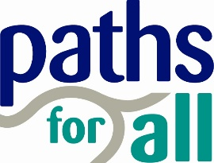
Restarting Health Walk Frequently Asked Questions

- An issue I am concerned about is that we have a number of people I know who have had shielding letters but have been out walking.

Shielding has been paused from 1st August and those who were previously shielding now have to follow the same guidance as the general population. They are advised to stick closely to the guidelines to minimise risk. In areas of increased local restrictions, those previously shielding have been asked to be particularly vigilant. Details of the guidance for those shielding can be found here.

- We were wondering what the thoughts were on walkers and volunteers who were over 70 coming back to take part in or lead walks? They are in the moderate risk category.

All walkers and volunteers should at all times be encouraged to follow government advice. It is an individual’s choice whether or not to participate in Health Walks, providing they act in accordance with the Walk Agreement. Individuals are encouraged to assess the likely and possible risks of participation (and non-participation) depending on their own health and personal circumstances. They should consult a medical professional if unsure.

- Will we need to add symptoms into our Walk Agreement for a point of reference and reminder?
Yes, we have developed an amended Walk Agreement Card that asks Walkers to confirm that they don’t have symptoms and shouldn’t be self-isolating as per Government guidelines. The agreement should be read out at the start, or circulated in advance, and it should be made clear to walkers that participation in the walk implies consent with the statement. Walkers should also agree to be willing to have their contact details passed on if required for Test and Protect purposes if a group member goes on to develop symptoms.
- How should we be managing falls during walks when physical distancing is in place?

If someone falls and they need emergency medical attention, volunteers must call 999 as normal. In situations where there is no need for immediate medical attention, or for minor first aid only, Public Health Scotland’s advice for volunteers is ‘At times you might be carrying out very specific activities, out with a premises, where it is not possible or practical to guarantee the minimum of 2 metre social/physical distancing measures. In these circumstances we recommend that you read the Scottish Government advice on facial coverings.’ We recommend that volunteers carry a face mask or covering and hand sanitiser for this purpose, but no one should feel obligated to put themselves in a position in which they feel uncomfortable.

- Are face masks/coverings being recommended? Although we are outdoors physical distancing may be difficult?

No, evidence suggests that there is not a significant benefit of wearing face masks/coverings outdoors, unless in an unavoidable crowded situation where there may be some benefit. While walkers are observing the 2m distance this will not be considered a crowded situation. However, it is a personal choice and some people may feel safer wearing a face mask/covering. Walkers and volunteers are welcome to wear a face mask or covering if they wish.

- Can all of the Paths for All Strength & Balance exercises be done in an outdoor setting?

This partly depends on suitable outdoor furniture (benches, handrails etc) and a flat surface to stand on being available. Walkers should wear gloves or use hand sanitiser when touching outdoor furniture and wash hands when returning home. It may not be possible or safe to complete all exercises in all locations with all groups and physical distancing needs to be maintained at all times. A risk assessment should be carried out prior to demonstrating the exercises.

- Is attending a Health Walk in addition to the number of households that you are allowed to socialise with outdoors daily with physical distancing?

Yes - attending a Health Walk is in addition to the number of households that you are allowed to socialise with daily, as the organised sports guidance for coached groups (which health walks now come under) is separate from the Scottish Government guidance on meeting other households socially.

- Can I still attend a Health Walk if there is a local lockdown in my area?

Yes – local lockdowns restrict social activity in people’s homes and are separate from the organised sports guidance for coached groups, which health walks come under, so you can still attend a health walk even if there is a local lockdown in your area.

- How long should the walk registers with phone numbers on them be kept after the walk?

The full details should be kept for 21 days, in case required for Test and Protect purposes, and then the phone numbers should be securely destroyed. Paths for All requests that projects keep names of those who have attended walks for at least 6 months afterwards in case they are required for insurance purposes and that any accidents or incidents that take place should be recorded by projects and sent to us if they use our insurance. An easy way to record walker names is to use the Walk Register function on the Walkers Database, so long as walkers’ contact details are up to date and recorded on the database.

- If there is an accident or incident, should any Covid-19 precautions/measures that are taken be recorded on the Paths for All Accident/Incident Report Form?

Yes, please record any Covid-19 precautions/measures taken on the Paths for All Accident/Incident Report Form, for example physical distancing measures, wearing a face covering, using hand sanitiser etc. As mentioned above, Paths for All requires that any accidents or incidents that take place on a health walk should be recorded by projects and the form sent to Paths for All if they use our insurance or kept by the project if they use their own insurance.

- Some groups/volunteers are not comfortable with restarting at the current time – is that OK and do you have any tips to increase their confidence?
Absolutely. As always on Health Walks, it is important that everyone feels comfortable and is able to go at their own pace – and this includes returning to walking, and leading walks, only when people feel comfortable to do so. As always, it’s good to keep in contact with your Walk Leaders and walkers as much as you can. There are a few things you can do to help build walker and Walk Leader confidence. For Walk Leaders, you may find it helpful to organise a small group walk which brings together volunteers to review routes and risk assessments and get used to walking in a physically distant fashion. Some coordinators, where they have capacity, have also chosen to attend a group’s first few walks to provide extra support. You could provide your volunteers with the option to undertake smaller group or buddy walks, or a ‘taster’ walk without having to commit to returning to their role on an ongoing basis. You could also organise video calls which bring together volunteers who have returned to walking and other volunteers so they can chat through their experiences and concerns together. Discussing together, and involving your volunteers in your decision-making process, will help to ease fears.

For walkers, you may find it helpful to capture pictures and quotes from walkers and volunteers who have returned to walking to showcase their experience. Taking photos of groups out walking (where they provide permission) and sharing these may help walkers and other stakeholders have a greater understanding of what to expect on your walks. There is also a role for ongoing communications via email, social media, telephone calls and video calls to make sure – even if walkers choose not to return at this stage – that they do not feel left behind.

- Have any projects issued PPE to volunteers to use in case of an emergency and do you have any advice on where to obtain it?

We advise in our guidance that volunteers carry a mask and hand gel in case of an emergency, but that no one should feel under any pressure to deal with a situation that they feel puts them at risk. We know that a number of projects across our network have chosen to provide masks, hand gel and gloves to volunteers to increase confidence. You may wish to speak to your local community pharmacy to see whether they may be able to support you to access these items. If you would like to offer PPE to your volunteers and are struggling to access this locally, you can speak to your Development Officer who may be able to offer further advice.

- Do the Walk Leaders have to read out the whole Walk Agreement at the start of every walk, as it’s quite long and some walkers are hard of hearing?
As an alternative to reading out the whole Walk Agreement, you can share it with walkers in advance (via post, email, social media, WhatsApp, etc) and just highlight the key at points the start of the walk as a gentle reminder. On the day, Walk Leaders can check everyone has read it and is happy to comply before setting off.
- Is it helpful to split into smaller groups rather than going up to the maximum number and do you have any suggestions for managing this?
Just because we can walk in groups of up to 30 doesn’t necessarily mean we should! Factors to consider regarding group size include how many people can safely maintain 2m distance from each other on a particular route, the ratio of walkers to available Walk Leaders, the busyness of the route, consideration towards other path users, what your Walk Leaders feel is manageable, and what walkers feel comfortable with.
If you decide to break a large group into smaller groups, you could create “bubbles” where the same people walk together each week, stagger the start times (if following the same route), start at the same time but split into different routes, or create a rota where walkers attend on alternate weeks or in ‘blocks’ (eg of four weeks in a row). If you add additional days, times, meeting points etc to create more, smaller groups please remember to update the Walkers Database with your walk details, since this information is displayed on the Paths for All website.
If you’re not sure what the optimum number of walkers is, you could trial a walk just with your Walk Leaders, see how it goes and act on their feedback. And there’s always the option of buddy walks if people prefer to walk one-to-one.
To manage walker numbers, some Health Walks use a booking system (via phone, text, Messenger, WhatsApp, social media, or an online system like Doodle Poll or Eventbrite) to allow walkers to book a place in advance. Using a mixture of methods can help level the playing field if some walkers are less confident in using IT. For larger projects, where there are a lot of walkers to coordinate, Walk Leaders could help manage bookings for their walk.
- On buggy walks, does the maximum number of 30 participants include babies/toddlers?
Yes, on buggy walks, the maximum participant number of 30 includes babies and toddlers. As with all health walks, groups should be considerate of other path users.
- Do you have any tips for reminding walkers to maintain physical distancing?

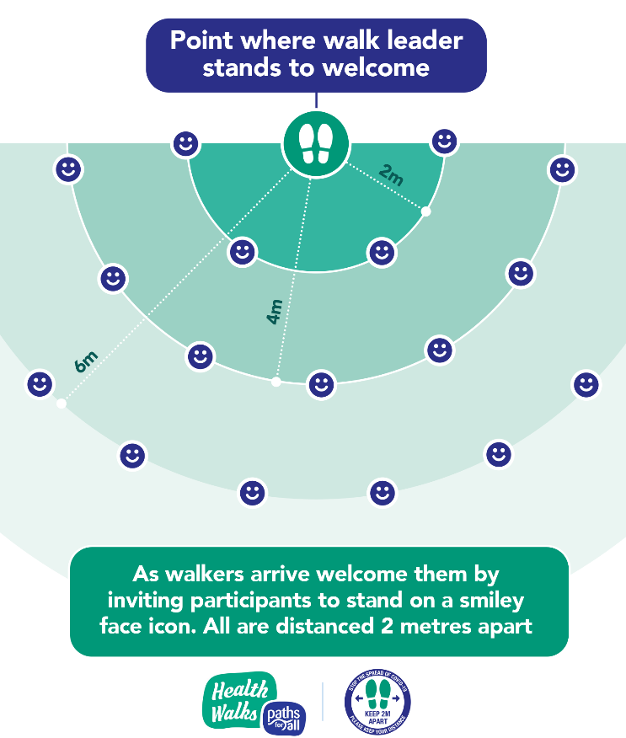
It’s a good idea for Walk Leaders to remind walkers how far 2m is at the start of the walk. Some groups have used 2m lengths of string or walking poles to do this. You can do this by arriving a couple of minutes early. Take with you a pre-measured (with 2m, 4m, 6m marked) piece of string and something to mark the spot such as a piece of chalk, floor stickers or pebbles. It is easier to do with two people. Stand on the point where you will welcome you walkers and put a marker. Then using a pre marked piece of string draw a semi-circle around the maker at 2m, then 4m, then 6m etc Continuing out like ripples in a pond. Then with the 2m section of string, put a marker along each semi circle.
Please be considerate of other pavements users. And finally consider which way you as the Walk Leader wants to go when starting the walk once everyone has arrived.
People have a personal responsibility to follow the government guidance and we can remind people of this guidance however responsibility remains with the individuals.

More questions? Get in touch with your local Development Officer who will be happy to help.

Useful Links
Scottish Government Guidance on Phase 3 Restrictions
https://www.gov.scot/publications/coronavirus-covid-19-phase-3-staying-safe-and-protecting-others/pages/overview/
Official NHS Advice on Covid-19, Guidance for Different Groups and Physical Activity
https://www.nhsinform.scot/illnesses-and-conditions/infections-and-poisoning/coronavirus-covid-19
https://www.nhsinform.scot/illnesses-and-conditions/infections-and-poisoning/coronavirus-covid-19/healthy-living/coronavirus-covid-19-physical-activity
Support and Resources for Volunteering during Covid-19
https://www.volunteerscotland.net/covid-19/
Information and Resources on Best Practice in Reducing Covid-19 Risk while Volunteering
https://www.scdc.org.uk/supporting-communities-safely
Paths for All’s Covid-19 statement relating to our work and walking activity
https://www.pathsforall.org.uk/news/news-post/our-response-to-covid-19

