Promotional pack for organisers
This short pack will help you:
- promote the Step Count Challenge within your workplace, encouraging colleagues to take part
- share positive messages about the benefits of being active at work with colleagues
- promote good news stories about your organisation externally

1. The Step Count Challenge logo & graphics
Use our logo and graphics to help share the key messages about the challenge and attract your colleagues to take part.
You can download them here: https://www.pathsforall.org.uk/mediaLibrary/other/english/step-count-challenge-graphics.zip
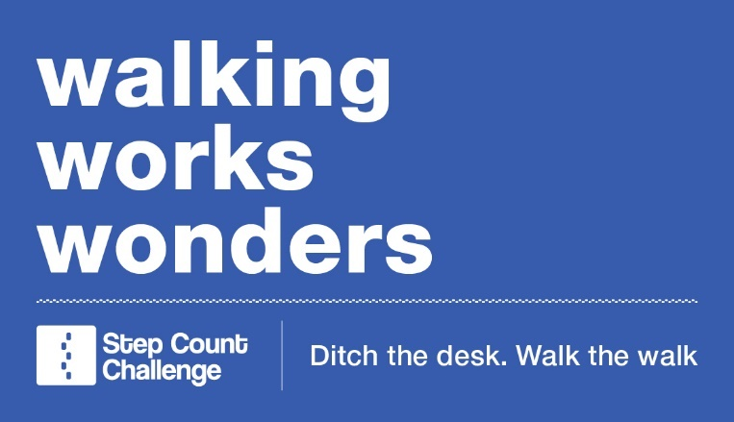

2. Staff newsletter/intranet content
Tailor our draft content to use in your internal communications with staff about the Step Count Challenge. Your text could include:
Let’s move more at work!
We’re taking part in Paths for All’s X week Step Count Challenge, starting on XX – will you join us? The challenge is designed to help us walk more during our working day by logging our steps in teams of 5 and setting mini challenges and targets each week.
The benefits of walking more during the working day are huge. Spending time outdoors can help to clear your head and boost your mood, helping you to feel more productive and focussed. The challenge is a great opportunity for us to get together and stay connected, having some fun along the way.
To sign up contact xxx
You could include a link to our Step Count Challenge explainer video which briefly describes how the challenge works: https://vimeo.com/497653358

3. Sample social media posts
Social media is a great platform to shout about your success and raise awareness on the benefits of being active at work. Use these samples posts to tell your followers about the steps you are taking for staff health and don’t forget to tag us @step_count.
We’re taking steps to a more active, happy and healthy workforce by taking part in the @step_count challenge #StepCountChallenge
We’ve signed up to the @step_count challenge to encourage our staff to take breaks from work to get outside, enjoy fresh air and feel good #StepCountChallenge
We’re taking part in the @step_count challenge to help our staff move more and sit less at work making them feel happier, less stressed and more productive. #StepCountChallenge
Our workplace is doing the @step_count challenge to help our colleagues stay connected and have some fun together #StepCountChallenge

4. Sample press release
Share a positive news story about your workplace with local or national press by editing our sample press release. This release can be used before or during the challenge. Try to accompany your release with a photo.
{insert organisation name} going an extra mile for staff’s health and wellbeing
{insert organisation name} is taking part in a fun workplace walking challenge to boost staff’s health and wellbeing.
{insert how many people taking part} employees at {insert org} have formed virtual teams and will motivate each other to get moving during the working day as part of the Step Count Challenge, an initiative from walking charity Paths for All.
Teams will be racking up their step counts with things like lunchtime walks, active breaks, walking meetings, and standing screen breaks during the {four week or eight week} challenge.
{name of organisation’s spokesperson} said: “{insert org quote outline why you’re taking part, in what way are staff engaging, and why health and wellbeing of staff is important to the organisation.}
Recent findings from UK workplaces reveal that half of all employees experience poor mental health at work, including stress, anxiety and depression. Regular walking can reduce the effects of poor mental health, particularly walking in greenspace.
Paths for All run two national Step Count Challenges a year, one in the spring and the other in the autumn. It also offers bespoke Step Count Challenges which allow organisation to run their own, in-house challenge at any time. The aim is to bring colleagues together to motivate each other to walk more and be more active and reverse the trend of sedentary behaviour at work.
Frances Bain, Walking for Health manager at Paths for All said: “Fun, connection with colleagues, and feeling the benefits of walking and being more active throughout the working day are what the Step Count Challenge is all about.
“The workplace is where the majority of us spend a great deal of our time, so it’s incredibly important that staff take a break from the screen and employers put wellbeing at the forefront of their mind.
“Walking is one of the best things we can do for our physical, social and mental health. It’s free, you don’t need special equipment, and it can be easily incorporated into the working day.
“Research shows that employees who are physically active in and around the working day take fewer sick days, are more motivated and productive, and are more able to concentrate, so walking is not just good for us, it’s good for business.
“Challenges like this help businesses put their staff’s health and wellbeing at the heart of what they do while making walking and moving more interactive and social so I’d encourage other businesses to follow {insert organisation name}’s lead.”
To find out more about the Step Count Challenge, visit www.stepcount.org.uk, or for more information on how Paths for All can help support workplaces to be more active, visit www.pathsforall.org.uk/workplacewalking.

Questions?
If you have any questions or would like some help to promote your good news then get in touch with our Communications Team at communications@pathsforall.org.uk

