Buddy Walk Guidance 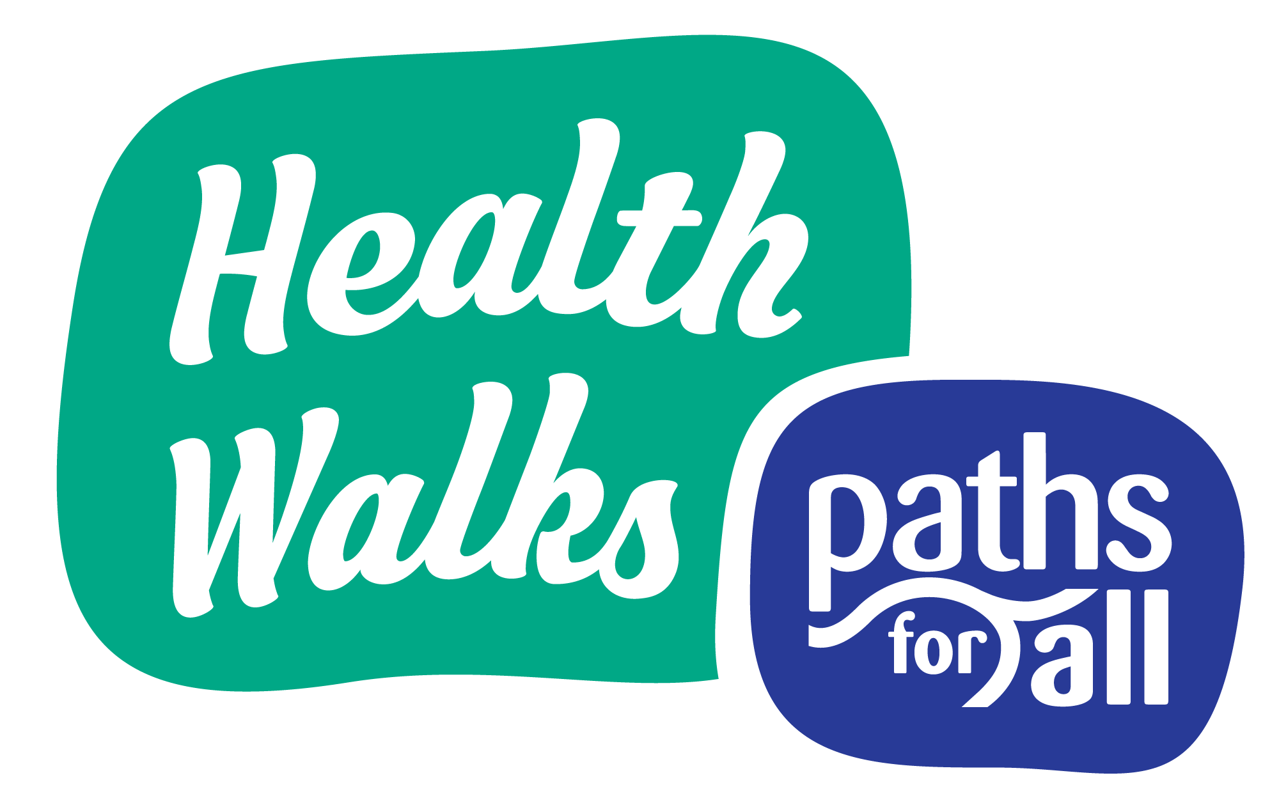
Buddy Walking is simply a system whereby two people pair up for the duration of a walk and can be delivered by Health Walk projects. This is something that Health Walk projects can now consider starting under the easing of lockdown restrictions as one way to get back to offering Health Walk activity within the physical distancing restrictions or where walkers and volunteers feel anxious about returning to a group setting.

Following the lockdown, Buddy Walking may prove particularly beneficial to walkers who feel unsure or under-confident about their own fitness or condition or have concerns about mixing with many people in a typical walking group.

This guidance covers Buddy Walks operating within the existing structure of a Health Walk with either the buddying up of a project staff member or volunteer Walk Leader 1 to 1 with a walker or alternatively, walkers from the group buddying up with each other to walk, to provide motivation and social support for walking whilst they wait for their group walks to restart or as an alternative to attending group walks.

Prior to the restart of Health Walks, most Health Walk Co-ordinators will have contacted existing walkers about returning to their group and during this process will have been able to gauge those participants that may like or need the reassurance of a Buddy Walk. The buddying up / matching process needs to be carefully considered and managed by the project Co-ordinator in liaison with Volunteer Walk Leaders to ensure a safe and enjoyable return to walking. The guidance for Volunteer Walk Leaders during Covid-19 should be circulated and adhered to during any Buddy Walking activity.

For all types of buddy walking general factors to be considered include:
- The location of the walker and volunteer and ease of meeting up.
- How will those paired as buddies get on? Do they already know each other?
- Would someone feel more comfortable walking with someone of the same gender?
- Are leaders and walkers alike happy to share their phone numbers in order to schedule walks?
- Any walking activity needs to comply with the guidelines on physical distancing

Project staff member / volunteer Walk Leader

When planning Buddy Walks, projects should:

- Ensure a risk assessment has been completed for the walk considering the existing COVID-19 guidance and ensuing that appropriate physical distancing is possible during the walk. The Risk Assessment Template (Covid-19) can be used.

- Make sure that the Project Co-ordinator or another volunteer knows where they are going and when they are expected back.

- Make sure they have the contact details for the Project Co-ordinator and the person they are walking with, with them.

- Ensure the leader takes a mobile phone with them on the walk.

- Read the updated Paths for All Health Walk Agreement out to the walker prior to starting the walk and confirm that they are happy to proceed.

- Any issues or concerns the leader has in relation to the walks and/or the matching process should be communicated to the Health Walk Project Co-ordinator as soon as possible.

- Volunteers should also be mindful of dealing with information that might be disclosed during a walk. Whilst keeping it confidential, the leader may be exposed to information that is of concern and feel that the walker needs further support- ensure that they know where suitable sources of support are e.g. Samaritans and potential training that they could access e.g. SafeTalk. The leader may in turn need support from their Co-ordinator in these situations.

Walkers Buddying Up
While walkers are waiting for their group Health Walks to restart, many may be keen to connect with other walkers and volunteers and begin to increase fitness and activity levels. Under these circumstances, an informal buddy walk programme may be possible where group members are put in touch with another walker by the Project Coordinator and with prior consent, to arrange and take part in a one to one walk in their local area. Many walkers will already know and be friendly with the weekly regulars in their group and this will allow them to socialise whilst looking out for each other out with a large grouping. These walks would be outwith the scope and procedures of the Health Walk project and walkers would be responsible for their own safety during the walk, although all would be expected to follow physical distancing guidelines.

