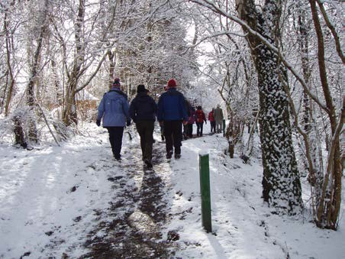Planning health walks in winter

Active Cairngorms Project

Weather plays a big part in organising a health walk programme. Advance planning for icy and stormy days can help keep everyone active and in touch over the winter months.

If you stop your health walks in winter, then at some point you will have to start again! For people struggling with their fitness it can be hard to become re-motivated, and the falls risk for older adults increases after a break from walking. Moreover, the social contact within the group can be a lifeline and what walkers enjoy most, so stopping your walks may not be the best solution.

We have pulled together some ideas to help you manage your health walks in winter.

Planning and communicating changes
Keep an eye on the weather forecast and have a bad weather plan in place in case you need to cancel your regular health walks.

Discuss weather conditions with your Project Coordinator and other Walk Leaders before the walk and decide if you think it is appropriate to go ahead. If you are out and the weather worsens it is fine to call a halt to the walk and go back for a cup of tea instead.

You could set up a Facebook page to notify regular and potential walkers of any changes to the planned walk.

If you have to cancel a walk, ensure a Walk Leader is at the usual meeting point, or a poster is hung up and staff at the meeting venue informed so that they can tell any walkers who turn up.

Keeping everyone active
If you decide to walk on bad weather days, stick to routes that are sheltered, less likely to flood and pavements and paths that have been gritted or cleared and are free of ice. Avoid paths with trees beside them if it is very windy.
You can shorten the walk so people are spending less time out in bad weather. Encourage walkers to wear layers of warm clothing, hats, gloves and scarves. It’s a good
idea for Walk Leaders have some spare hats, gloves and scarves to lend out. Have hot refreshments available after the walk.

Groups that walk in the evening can still do so in winter using well lit streets.

Introduce and use Paths for All’s Strength and Balance exercises indoors as a group, to strengthen muscles and improve balance. Training is available and Scottish Health Walk Network members can apply for a free Starter Pack of the resources. For more information, please see: www.pathsforall.org.uk/strength

Go on an indoor health walk in a shopping centre.

Organise an indoor walking football session - see www.walkingfootballscotland.org/ for information.

Keeping everyone in touch
Visit a local community class to encourage walkers to try something new.
Arrange a talk by a health professional or other local speaker for the group to enjoy. Organise a slide show of photographs to celebrate walkers’ achievements and have fun
reminiscing about previous days out.

Use the time to plan social activities, Walk Leader rotas or training days. Our Themed
Walks and Events Calendar might give you some ideas for planning your walks.

You could also get together to talk about the project’s development or get feedback and suggestions from leaders and walkers. The Project Coordinator could also use this time to recruit new Walk Leaders from among the walkers.

Project Coordinators could organise a thank you event for volunteers. Free Volunteer
Awards certificates and gifts can be ordered online from Paths for All.

Arrange a trip to an indoor site of interest to enjoy a day out as a group of leaders and walkers and develop a stronger team.

Further information
The Scottish Government has a website which gives more information about getting ready for winter. Visit www.readyscotland.org to find out more.

For advice on path improvements, please contact our Technical Officer on technical@pathsforall.org.uk or 01259 222 330.

To discuss gritting and snow clearance, please contact your Local Authority.

Acknowledgements - We would like to thank Heather Macleod, Good Move Walking Development Officer, for sharing her advice to walk leaders which has been included in this document.

